

COMP7039 – Agile Processes

Individual Assessment – Git (20 %)

Name: Deirdre Connolly

Class: CS3

Please edit and submit this document.

Submission Instructions:

Submissions to be made on Canvas by:

Friday 25th October 2019 @ 5.00pm

- Zip your assignment folder containing THIS edited document with screenshots and a zip archive file of your git folder including the hidden .git folder.

- Name the compressed file using the following convention: joe_bloggs.zip

10% will be deducted from submissions that do not comply with these instructions

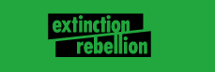

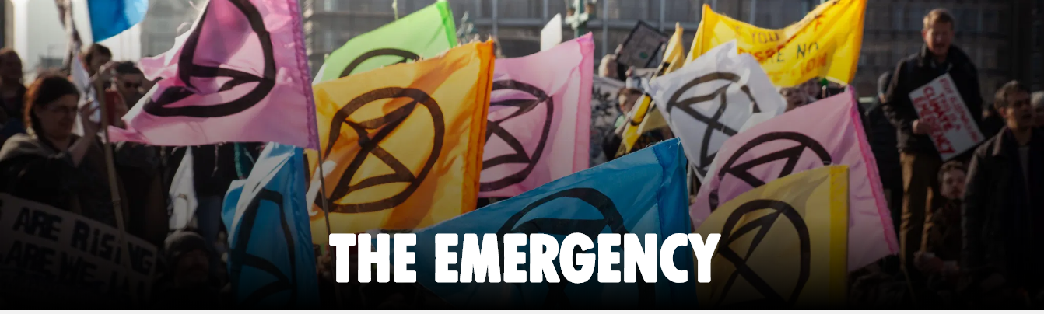

The Extinction Rebellion group in Ireland want to create a web page to promote events planned for the region. Not all future events are known at this time so they
want to have it developed in stages.

Create an initial web page and subsequently update it in stages, using git to manage the changes.

NB – show screenshots of all git commands executed!

- Create a very basic HTML home page document for Extinction Rebellion campaign. The page only contains the name “Extinction Rebellion” and its address. Create and configure a git repository and commit the initial version of the page.

- Add items to the web page. Create and commit 5 variations, each time committing to the repository.

- Add a second file to the repository e.g. a css file to change the look of the page and commit that css file also with two revisions of the css file. Additionally, revise the html code to use the css file. Thus, there are now 7 versions of the web page.

- Demonstrate rolling back to view version 4.

Create a branch from version 6 and modify the web page to demonstrate a new variation for the customer.

- Demonstrate merging, versioning and stashing

(4 marks each, 20 marks total)

NB:
“By submitting this electronically, using an account & password only I have access to, I hereby certify that this material which I now submit for assessment is entirely my own work and has not been taken from the work of others, save and to the extent, that such work has been cited and acknowledged within the text of my work.”

CIT has access to plagiarism tools and these may be used on submitted assignments. The use of ‘rent a coder’ type services in preparing your assignment is forbidden.

Demo
You may be asked to demo your assignment in the lab.

Screenshots
See below for example of screenshots to use when submitting this assignment – please ensure the command prompt uses your login id/name or student ID.

Place each item of the assignment on a separate page and show screen shot(s) of how you achieved the task item. List steps executed to describe what you have done.

Example

Task “initialize a Git repository and set the user’s name and password”

1(a) Initialize a Git repository and set the user’s name and password.

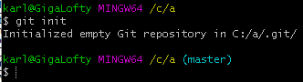

Description:
Use the git init command to create an empty git repository.

Enter the git config command to set the username and email address:

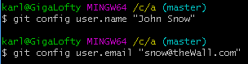

Use the git config –list to confirm that the name and email address have been set.

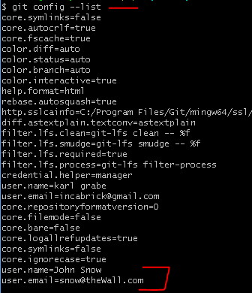

(a) Create a very basic HTML home page document for Extinction Rebellion campaign. The page only contains the name “Extinction Rebellion” and its address. Create and configure a git repository and commit the initial version of the page.

Use the git config command to configure the repository settings, including setting a username and email address

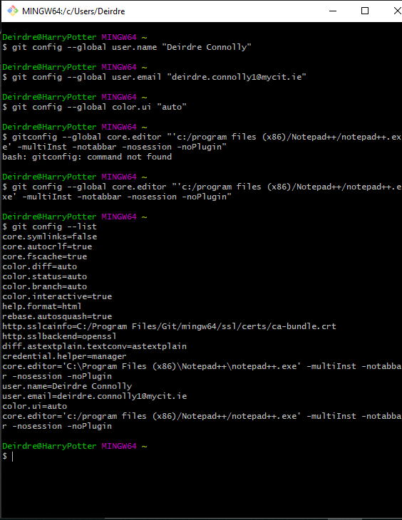

Create a directory for the project using mkdir git

Change to that directory using cd

Initialise a new git repository using git init

Check the status of the repository using git status

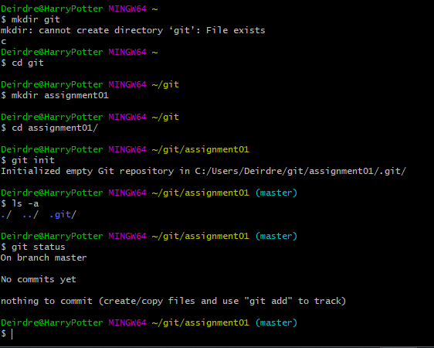

Create a README file using notepad README.md

Check status using git status

Add all files to be tracked using git add .

Check status again to see changes to be commited

Use git commit -m “message” to commit the changes

Use git log to view what happened

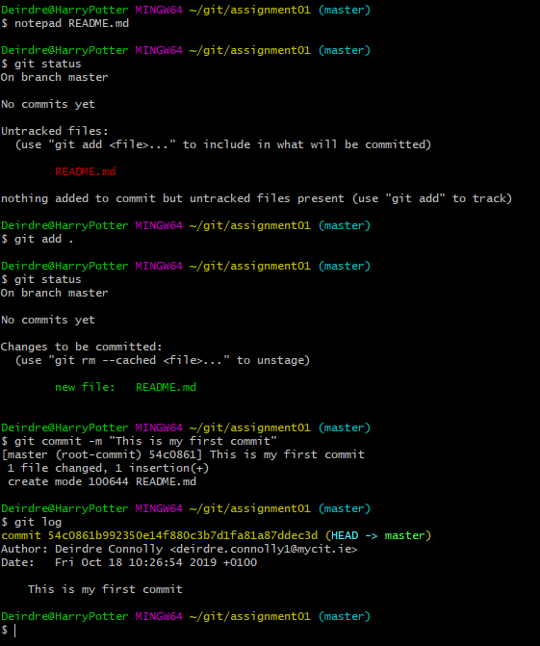

Create a HTML file using notepad extinctionrebellion.html

Check status using git status

Add all files to be tracked using git add .

Check status again to see changes to be commited

Use git commit -m “message” to commit the changes

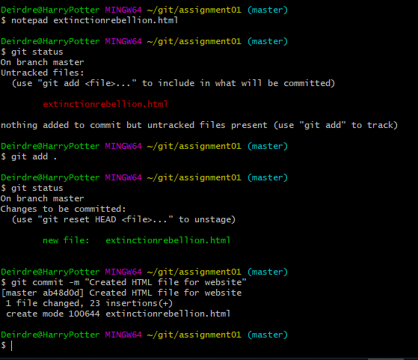

Basic webpage showing title and welcome message

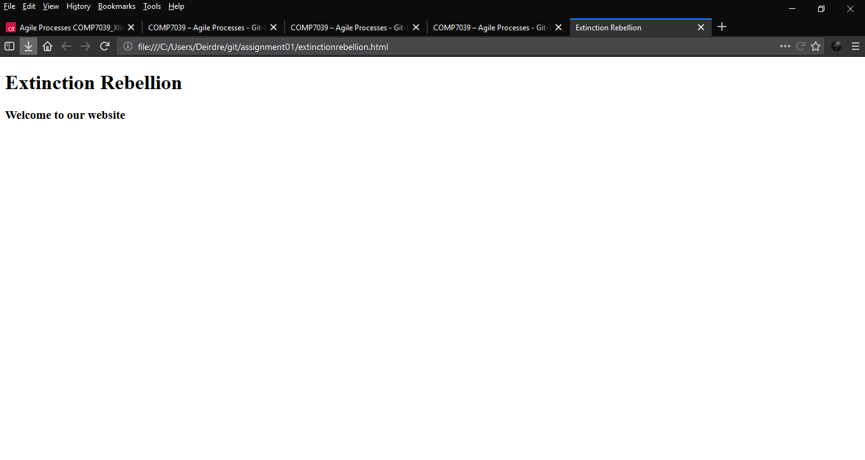

(b) Add items to the web page. Create and commit 5 variations, each time committing to the repository.

Modify extionctionrebellion.html to update webpage

Between each change, stage and commit using git add extionctionrebellion.HTML and git commit -m “message”

Use git status to verify changes

- Created and added favicon

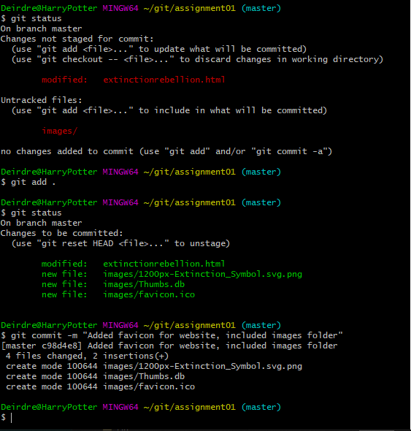

- Added a paragraph

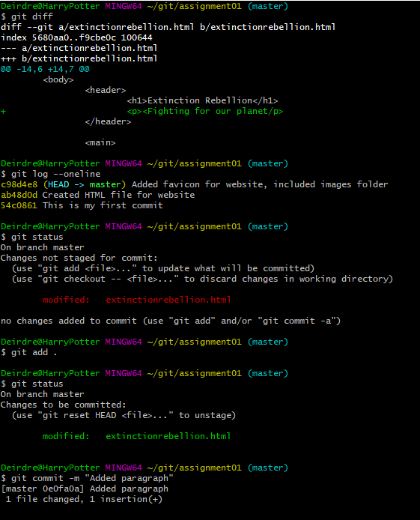

- Added footer with author details

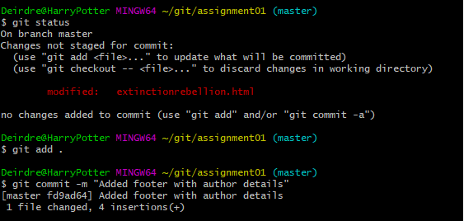

- Modified footer to include more details

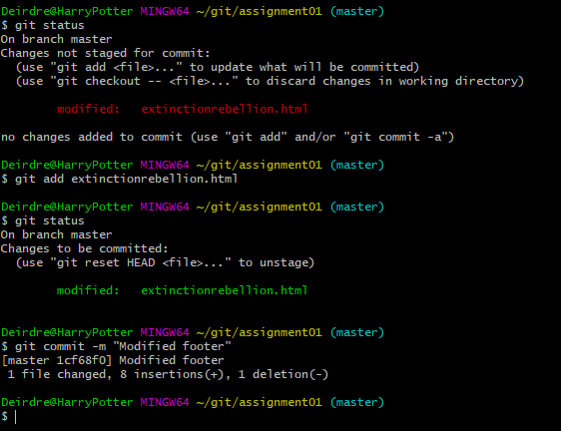

- Added another paragraph

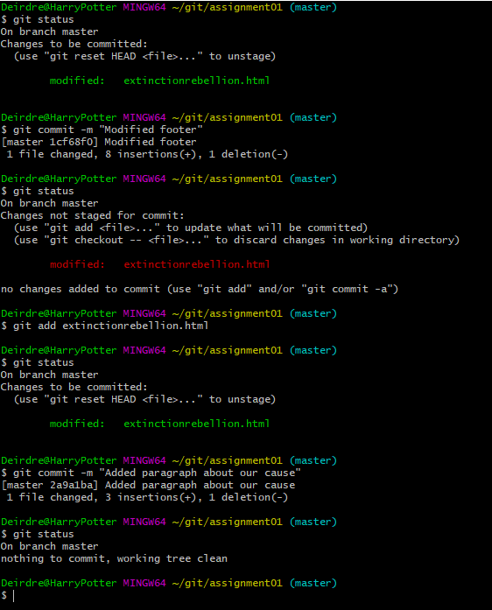

(c) Add a second file to the repository e.g. a css file to change the look of the page and commit that css file also with two revisions of the css file.
Additionally, revise the html code to use the css file. Thus, there are now 7 versions of the web page.

Create a CSS file in the directory, include link in the HTML file

Between each change, stage and commit using git add extinctionrebellion.HTML and git commit -m “message”

- Added CSS file

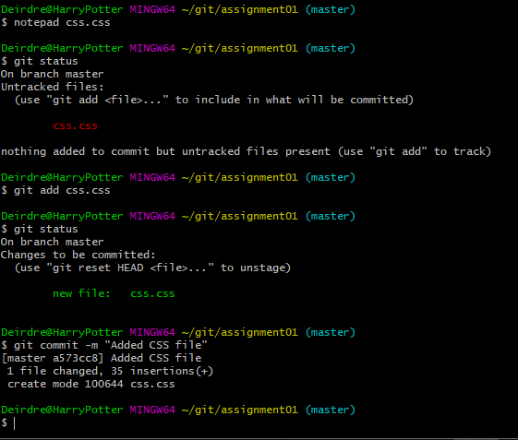

- Added styling changes to CSS file

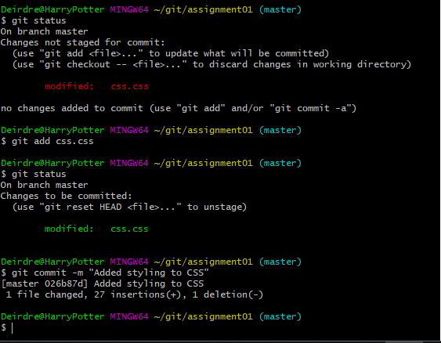

- Added CSS link to HTML file

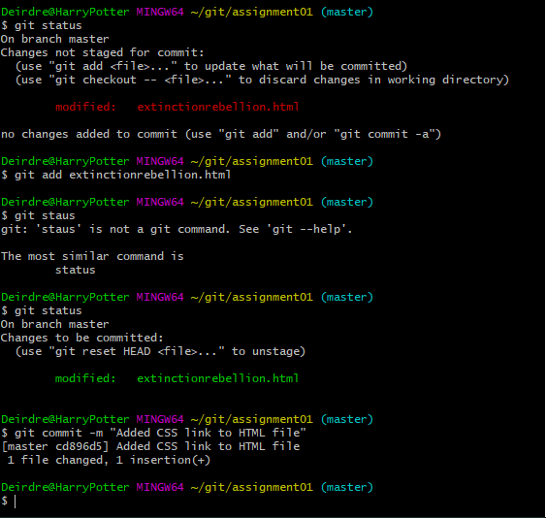

Webpage with CSS

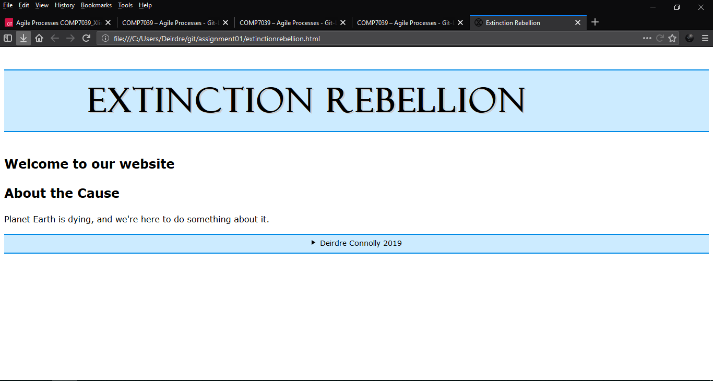

Use git log –oneline to view all activity

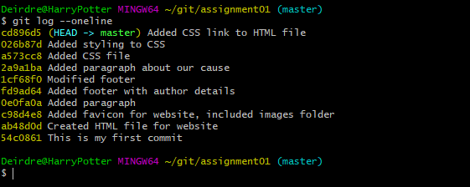

(d) Demonstrate rolling back to view version 4.

Create a branch from version 6 and modify the web page to demonstrate a new variation for the customer.

Change to version 4 using git checkout <id>

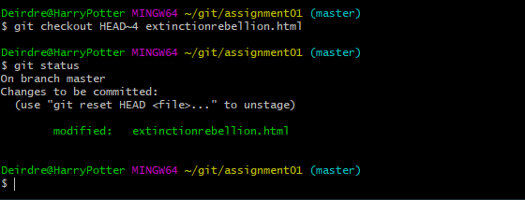

Change to version 6 using git checkout <id>

Create a branch using git branch version_6

View branches using git branch

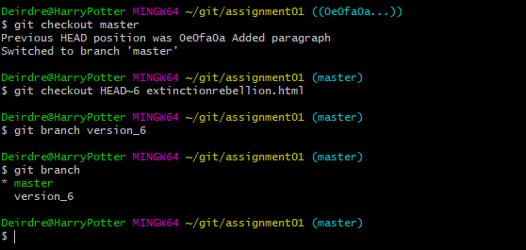

Make change in version 6 branch, and commit

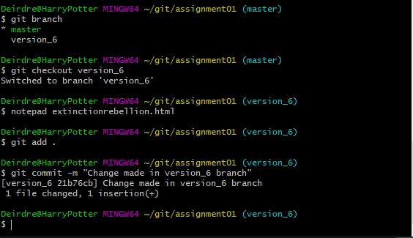

Webpage from version 4

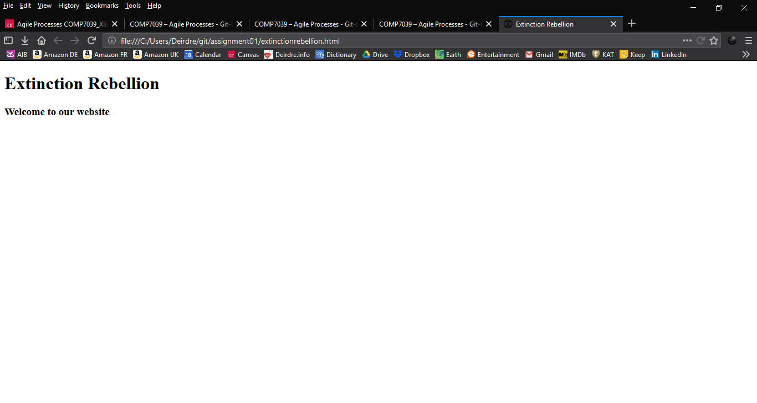

Modified webpage

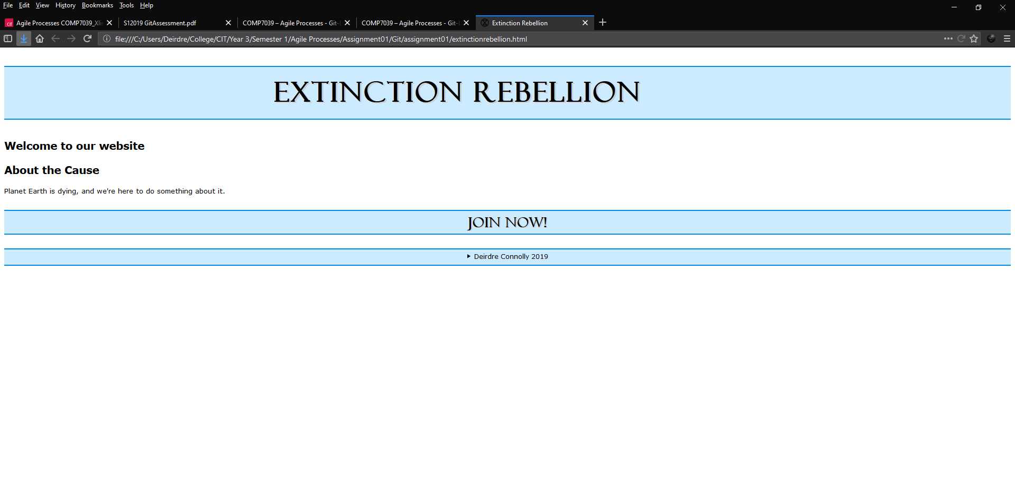

(e) Demonstrate merging, versioning and stashing

Change to master using git checkout master

Merge branch using git merge version_6

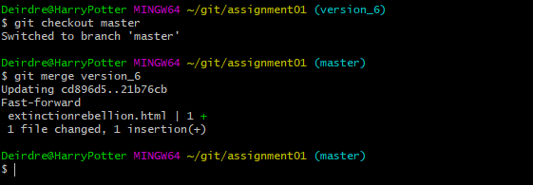

Make change to README file

Change branch using git checkout

Use git stash command to take the dirty state of your working directory (saves it on a stack of unfinished changes that you can reapply at any time)

Use git status

Change branch again

Use git pop to remove changes from the stash, and reapply them to previous working copy on master branch

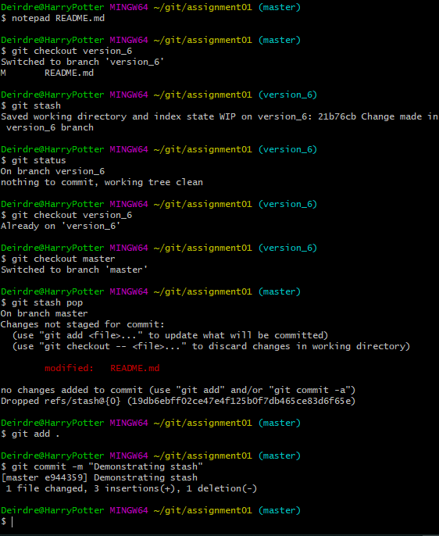

Use git tag -a “tag” -m “message” to create a tag identifier

Use git tag to list all tags

